**Prevalence of Musculoskeletal Disorders among Auto Drivers and their association with Ergonomic risk factors and Quality of life, in Chennai**

Project submitted to



**SRI RAMACHANDRA INSTITUTE OF HIGHER EDUCATION AND RESEARCH**

**(DEEMED TO BE UNIVERSITY)**

**(Declared Under Section 3 of the UGC Act, 1956)**

**[NAAC ACCREDIATED A GRADE – CGPA]**

**Porur, Chennai- 600 116**

In partial fulfilment of the requirements for the degree of Master of Public Health

(Occupational and Environmental Health)

**NAME: MR SANJAY.N**

**Reg. No: H0123028**

**Masters of Public Health**

**Department of Environmental Health Engineering**

**Faculty of Public Health**

**Sri Ramachandra Institute of Higher Education and Research**

**Porur, Chennai-600116**

**MAY- 2025**

**Under the guidance of**

**MR. P. RAJKUMAR**

**Lecturer, Department of Environmental Health Engineering**

**Sri Ramachandra Faculty of Public Health**

**Sri Ramachandra Institute of Higher Education and Research (DU)**

**Porur, Chennai-600116.**

**Prevalence of Musculoskeletal disorder among Auto Drivers and their association with Ergonomic risk factors and Quality of life, in Chennai**

Project submitted to



**SRI RAMACHANDRA INSTITUTE OF HIGHER EDUCATION AND RESEARCH**

**PORUR, CHENNAI-600116**

In partial fulfilment of the requirements for the degree of Master of Public Health

(Occupational and Environmental Health)

NAME: MR. SANJAY.N

Reg. No: H0123028

Master of Public Health

Department of Environmental Health Engineering

Faculty of Public Health

Sri Ramachandra Institute of Higher Education and Research

Porur, Chennai-600116

May- 2025

Guide: MR. P. RAJKUMAR Head of Department: Dr. S. SANKAR

Date: Date:

Place: place:

**Department of Environmental Health Engineering Sri Ramachandra Institute of Higher Education and Research**

**(Deemed to be university)**

Porur, Chennal-600 116

**BONAFIDE CERTIFICATE**

This is to certify that this project entitled **Prevalence of Musculoskeletal disorder among Auto Drivers and their association with Ergonomic risk factors and Quality of life, in Chennai** been completed under my supervision and guidance during the academic year 2024-2025

MR. P. RAJKUMAR

Lecturer

Department of Environmental

Sri Ramachandra Institute of Higher Education and Research

(Deemed to be University)

Porur, Chennai-600116

**DECLARATION**

I hereby declare that this project entitled “**Prevalence of Musculoskeletal disorder among Auto Drivers and their association with Ergonomic risk factors and Quality of life, in Chennai”** submitted by me, in partial fulfilment of the requirements for the degree of Master in Public Health, to Sri Ramachandra Institute of Higher education and Research (DU) is the result of my original and independent research work carried out under the supervision and guidance of MR. P. RAJKUMAR. Lecturer, Department of Environmental Health Engineering, Sri Ramachandra Institute of Higher Education and Research (DU) during the academic year 2024- 2025.

Date: Name: MR. SANJAY . N

Place: Chennai Reg. No: H0123028

Master of Public Health

Department of Environmental Health Engineering

Faculty of Public Health

Sri Ramachandra Institute of Higher Education and Research

(Deemed To Be University)

Porur, Chennai - 600 116

**ACKNOWLEDGEMENT**

**Words of thanks may be written but the heart of mine goes beyond in search of words to think.**

I lack in my wisdom to thank the incomparable wisdom of ALMIGHTY GOD for having confirmed his Blessing above.

I am thankful to the management of SRI RAMACHANDRA INSTITUTE OF HIGHER EDUCATION AND RESEARCH (SRIHER) and the Institutional Ethics Committee for having given me the ascent to begin my study.

I am grateful and indebted to my guide Lecturer Mr. P. RAJKUMAR, whose valuable guidance, academic, clinical, theoretical, motivational, moral support & encouragement in all tough situations without denying was been pivotal. Their content & suggestion in technical aspects, diagnostic procedures and interpretations greatly helped to finish the study.

I am thankful to DR. KALPANA BALAKRISHNAN, Director, WHO- Collaborating Centre for Occupational Health & ICMR- CAR, Department of Environmental Health Engineering, Sri Ramachandra Institute of Higher Education and Research (Deemed to be University), Pour, Chennai for her encouragement in completing this study.

I thank DR. S. SANKAR, Head of the Department, Department of Environmental Engineering, Sri Ramachandra Institute of Higher Education and Research (Deemed to be University), Pour, Chennai for his encouragement and support.

I thank Dr. KRISHNENDU MUKOPADHY AY, Professor and MPH course co-coordinator,Department of Environmental Health Engineering, Faculty of Public Health, Sri Ramachandra Institute of Higher Education and Research, for his valuable advice and guidance.

I thank Dr. VIDHYA VENUGOPAL, Professor, Department of Environmental Health Engineering, Faculty of Public Health, Sri Ramachandra Institute of Higher Education and Research, for sharing her valuable experience and knowledge during the academic course.

I thank Dr. VIDYA SHANMUGAM, Lecturer, in the Department of Environmental Health Engineering, Sri Ramachandra Institute of Higher Education and Research, Pour, Chennai for his valuable guidance and also for sharing their extensive experience during my entire course.

I Deeply thank Dr. P. VENKATESAN, Visiting Professor of Sri Ramachandra Institute of Higher Education and Research, who has cared a lot about statistics.

I thank Mrs. JAYACHELVI BABU, Senior Lecturer in the Department of Environmental Health Engineering, Sri Ramachandra Institute of Higher Education and Research, Porur, Chennai for her support in my academic activities.

I express my sincere thanks to my mentor Dr.. VIDHYA VENUGOPAL, senior Lecturer, and Dr. K. PAARI, Senior consultant (Occupational Health) in the Department of Environmental Health Engineering, Sri Ramachandra Institute of Higher Education and Research, Pour, Chennai for their valuable guidance and also for sharing their extensive experience during my entire course.

I thank Dr.G.hangavel, Assistant professar, in the Department of Environmental Health Engineering, Sri Ramachandra Institute of Higher Education and Research, Pour, Chennai for his valuable guidance and also for sharing their extensive experience during my entire course.

A huge thanks to Mrs. PARAMESHWARI, an administrator in the Department of Environmental Health Engineering, Sri Ramachandra Institute of Higher Education and Research, Pour, Chennai for her valuable guidance throughout my academic activities.

A special thanks to my ever-loving parents and friends for their love, prayers, and support in each and every step of my life. I thank my friend Hrithik Ram. J, V. Gokul, Sambath, aravinth vishwaraj , G.gladson, Bharathi priyan, Nanditha anandakumar for their never ending support and invaluable help throughout the course and dissertation.

As time has run in its endless flight, my gratitude goes to all who have directly or indirectly contributed to the growth of my project.

MR. N. SANJAY.N

**ABBREVIATIONS**

**MSDs** - Musculoskeletal Disorders  
**RULA** - Rapid Upper Limb Assessment  
**SD** - Standard Deviation  
**NMQE** – Extended – Nordic Musculoskeletal Questionnaire

**WMSDs –** Work Related Musculoskeletal Disorders

**SF-36 -** SHORT FORM - 36

**CONTENT**

|  |  |  |
| --- | --- | --- |
| **S.NO** | **TITLE** | **PAGE NO.** |
| 1 | INTRODUCTION | 10 |
| 2 | LITERATURE REVIEW | 14 |
| 3 | AIM & OBJECTIVES | 18 |
| 4 | RATIONALE | 20 |
| 5 | METHODOLOGY | 22 |
| 6 | RESULTS | 26 |
| 7 | DISCUSSION | 41 |
| 8 | LIMITATION | 45 |
| 9 | RECOMMENDATION | 47 |
| 10 | CONCLUSION | 50 |
| 11 | REFERENCE | 52 |
| 12 | ANNEXURE | 56 |

# **INTRODUCTION**

**Ergonomics**

Ergonomics is the science that seeks to improve productivity by reducing operator fatigue and discomfort and is concerned about the interaction between a person and their working environment. The design of aimed work systems, working environment, tools and machines ought to match the capabilities and limitations of the human being. Correctly applied ergonomic principles can avert a multitude of occupational health problems, especially the musculoskeletal disorders that arise in physically demanding or repetitive employment. Unfortunately, in loosely regulated informal employment sectors such as auto-rickshaw driving, there is little or no access to ergonomic awareness and supportive infrastructure. This lack of attention causes auto-rickshaw drivers to endure considerable physical stress, resulting in long-term health complications, diminished work productivity, and progressive decline in life quality.

**Work-Related Musculoskeletal Disorders (WMSDs)**

WMSDs are described as injuries or disorders of the body’s moving framework, such as muscles, nerves, ligaments, tendons, joints, cartilage or spinal discs which are incurred or aggravated by work-related physical activities. Work-related musculoskeletal disorders are cumulative in nature, arising over time as the result of repetitive motions, continuous exertion of force, static or awkward body postures, and vibration exposure, possible in occupations requiring sitting or tool use. WMSDs include lower back pain, chronic neck and shoulder pain, tendinitis. osteoarthritis of the wrist and hand, and knee and hip joints. These injuries are most common among drivers and other workers who perform physically demanding work without adequate rest or changes in task.

**Ergonomic Risk Factors in Auto Driving**

In the matter of auto drivers, their daily work consists of sitting within cramped vehicles for long hours and manipulating vehicle controls during traffic jams while enduring continuous whole-body vibrations due to poorly paved roads. Comfort is far from the priority for most auto-rickshaw manufacturers. Seats offer no lumbar support; drivers' legs are cramped, and the cabin as a whole does not allow the body to move naturally. Most drivers do not receive any instruction on postures, self-care, or basic ergonomics, which increases the likelihood of chronic musculoskeletal problems. Because of the nature of their occupation, this segment of the population tends to elude the protective mechanisms of labor and occupational health legislation, leaving workers unprotected and unsupported.

As with many other forms of work, auto driving comes with a distinct set of challenges that have varying levels of ergonomic consideration. Drivers utilize vehicles not meant for long drives and do not offer significant relief from bodily strain over prolonged use. There is no formal arrangement for breaks, rest-relief activities, or any rest that could aid health in the context of driving and operations. The persistent neglect of ergonomic principles means drivers have to work under these conditions, biologically, mechanically, and economically expending pain and exhaustion on a daily basis to support their income. Gradually, this pattern of neglecting physical care leads to more chronic problems like decreased health and work performance, reduced earning ability, and poor overall life satisfaction. The lack of support systems only makes the situation worse. As is typical, auto drivers have no health insurance, preventive healthcare, or routine medical check-ups. Many do not understand that their health problems stem from work—pain and discomfort are oftentimes rationalized as simply a part of aging or the result of a sedentary lifestyle. This leads to a lack of seeking timely treatment, making them remain in harmful work environments. In the absence of timely diagnosis and intervention, work-related musculoskeletal disorders (WMSDs) advance to more serious, sometimes irreversible, rehabilitative and mental health conditions. As a result of financial necessity, drivers tend to prioritize daily earnings over long-term health, forcing them to suffer in silence.

**Impact of Musculoskeletal Disorders on Quality of Life**

The toll of these latent occupational health issues has a direct impact on the overall auto driver’s quality of life. Physically, chronic pain and fatigue translates to decreased productivity, impacting not only work outcomes, but also social and family life activities. From a mental perspective, managing these health challenges on its own creates income uncertainty which leads to anxiety, irritability, and low moods alongside disrupted sleep patterns. Many drivers are reporting heightened feelings of frustration, isolation, and helplessness, especially when their deteriorating health becomes a barrier to work. The combination of unpredictable income, inadequate medical assistance, and reduced physical capacity culminate into an unpredictable spiral of economic distress and emotional turmoil. This decline in quality of life paints a stark picture of some social injustice. While workers in the formal economy enjoy some measure of workplace cubicle ergonomics, occupational health surveillance, and social protection, auto drivers as informal sector workers are left outside of these safety nets. Economically, they are regarded as secondary and their health and well-being are treated as an afterthought. Their role in the urban transport system is essential and yet they are usually overlooked in health and safety governance.

**Common health complaints among Auto Drivers**  
Auto rickshaw drivers, like other professional drivers, face a range of occupational health challenges due to prolonged exposure to urban traffic, pollution, and physically demanding work conditions. Musculoskeletal problems, especially lower back pain, neck stiffness, and joint strain, are frequently reported as a result of continuous driving, poor seating ergonomics, and repetitive use of limbs during vehicle operation. Respiratory issues such as chronic bronchitis and reduced lung function are also common due to constant exposure to vehicle emissions and air pollutants in congested city areas. Additionally, many auto drivers experience cardiovascular risks like hypertension and elevated cholesterol, which are linked to long working hours, irregular meal patterns, and high stress levels. Mental health concerns, including anxiety, irritability, and sleep disturbances, are often observed, driven by economic instability, traffic-related stress, and lack of social support. These health issues can significantly impact their quality of life and driving safety.

# **LITERATURE REVIEW**

**Literature review:**

**Anupriya P. Mohokar (2018)** conducted a cross-sectional study involving a survey of auto-rickshaw drivers to assess the prevalence of musculoskeletal disorders (MSDs). The findings revealed that the most commonly affected regions were the shoulders, neck, and lower back. The study identified key risk factors such as advancing age, years of driving experience, vehicle age, and a higher body mass index (BMI). It also noted that prolonged driving duration significantly increased the risk of developing MSDs. These results highlight the need for targeted ergonomic interventions and healthcare support for auto-rickshaw drivers. The study calls for preventive occupational health strategies tailored to this specific workforce.

**M. Stanley et al. (2022)** conducted a cross-sectional study surveyed occupational drivers to investigate the incidence of work-related musculoskeletal disorders (WMSDs). A significant proportion of drivers reported pain, particularly in the back, neck, and joints. Alarmingly, most of the drivers lacked any form of ergonomic training and did not seek professional medical treatment for their conditions. The study underscores the neglect of occupational health education and support among drivers. It recommends awareness campaigns and training programs to mitigate the risk of WMSDs. The findings emphasize the urgent need for proactive workplace interventions to improve driver well-being.

**Echezona Nelson Dominic et al. (2021**) conducted a cross-sectional survey reported an extremely high prevalence (95.8%) of WMSDs among mini-bus drivers. The back was the most commonly affected area. The study found variations in symptom distribution between different bus categories: BC drivers showed more neck and upper back issues, whereas BD drivers experienced more problems in the lower back, knees, elbows, and wrists. Key contributing factors included overwork, poor posture, fatigue, and general job dissatisfaction. The findings highlight the physical and psychological demands of professional driving. Improved work conditions and ergonomic reforms are crucial to reduce these health risks.

**Chen et al. (2021)** conducted an experimental study focused on measuring the effects of whole-body vibrations (WBV) on professional drivers. The results indicated a strong correlation between WBV exposure and spinal disc degeneration, particularly in the lower back. Repeated exposure to such vibrations during long driving hours significantly contributed to chronic lower back pain. The findings stress the importance of mechanical interventions such as improved vehicle seating and suspension systems. Reducing WBV could play a critical role in preventing spinal disorders among drivers.

**Taylor and Green (2020)** A cross-sectional survey by Taylor and Green revealed a high prevalence of musculoskeletal disorders (MSDs), particularly in the lumbar spine region, among occupational drivers. Long hours of driving and inadequate ergonomic support were cited as the primary reasons for lumbar spine strain. The study confirms that lower back disorders are a common occupational hazard in this group. It emphasizes the chronic nature of these conditions and their impact on quality of life. The authors recommend ergonomic modifications and regular physical assessments to combat the issue.

**Huang et al. (2022)** This longitudinal study tracked musculoskeletal health among truck drivers over time. It revealed that the lumbar spine was the most vulnerable area due to sustained ergonomic stress, including prolonged sitting and whole-body vibration. The study provides comprehensive evidence that long-term exposure to these risk factors contributes significantly to lumbar spine disorders. The results advocate for continuous health monitoring and workplace redesigns. Preventive strategies should include education, better seat ergonomics, and rest period regulation.

**Authors: Lee et al. (2020)** A cohort study was conducted to assess cardiovascular health among truck drivers. The findings showed a significantly higher incidence of hypertension and metabolic syndrome compared to the general population. These health conditions were linked to a sedentary lifestyle, poor diet, lack of physical activity, and stress from long working hours. The study emphasizes the intersection of occupational and lifestyle-related health risks. Regular screenings, wellness programs, and health education are necessary to reduce cardiovascular risks.

**Johnson and White (2021)** conducted a cross-sectional study evaluated the mental health of professional drivers suffering from chronic musculoskeletal pain. The findings revealed a direct association between persistent physical pain and increased levels of depression. Additionally, drivers reported a significantly reduced quality of life. The study highlights the often-overlooked psychological toll of chronic occupational pain. It advocates for integrated physical and mental health care approaches. Addressing both aspects can lead to improved health outcomes in drivers.

**Garcia et al. (2019)** conducteda observational study to examine sleep patterns in professional drivers. It concluded that poor sleep quality directly contributes to higher fatigue levels and impaired cognitive performance. Disruptions in circadian rhythm due to irregular work hours were a common cause. The study links poor sleep to increased accident risks and overall health deterioration. It recommends the implementation of sleep hygiene education and schedule adjustments. Promoting proper rest is essential for safety and well-being.

**Wilson et al. (2021)** This interventional study evaluated the outcomes of ergonomic training programs for professional drivers. The results showed notable improvements in posture and a reduction in musculoskeletal discomfort. Participants became more aware of body mechanics and workplace ergonomics. The study confirms that training interventions can serve as cost-effective solutions to reduce WMSDs. Regular reinforcement of ergonomic practices is recommended. The approach fosters long-term occupational health benefits.

**Barnes J, Thomas P. (2006)** conducted a study evaluated the quality of life (QoL) in individuals hospitalized due to road traffic accidents. Using both generic and trauma-specific health outcome measures, the authors assessed physical, psychological, and social impacts post-injury. Results highlighted significant reductions in QoL, especially among those with long-term impairments or psychological distress. The study emphasized the need for comprehensive rehabilitation addressing both physical and mental health. It also underscored differences in recovery outcomes based on road user type. These findings support integrating QoL assessments in post-crash care planning and trauma research.

# **AIM AND OBJECTIVES**

**Aim :**

To find out the Prevalence of musculoskeletal disorders and their association with ergonomic risk factors and quality of life among auto drivers in perambur, Chennai.

**Objectives :**

* Identify and assess the ergonomic risk factors associated with auto driving and their relationship with health outcomes
* To determine the association between driving duration, posture, and the occurrence of health issues, such as back pain, joint pain, and fatigue.
* To provide recommendations for ergonomic interventions, workplace improvements, and policy measures to enhance occupational health and safety for auto drivers.

# **RATIONALE**

**Rationale**

Auto drivers are exposed to numerous ergonomic risk factors, such as prolonged sitting, awkward postures, repetitive movements, and vibration from driving. These risks, coupled with extended work hours, insufficient rest, and poor access to healthcare, can lead to significant adverse health outcomes, including musculoskeletal disorders (MSDs), cardiovascular diseases, and mental health issues. Though they play a pivotal role in the transportation industry, which supports economic development by ensuring the movement of goods and services, only very few studies have been found to be conducted on the occupational health, in particular musculoskeletal health, of auto drivers in India. Hence this study strives not only to contribute to valuable addition of occupational health information to the research database in this unorganized sector, but also aims at providing meaningful suggestions towards improving the occupational health of auto drivers.

# **METHODOLOGY**

**Study design**: Cross sectional study

**Study location**: Perambur, Chennai

**Study population**: Auto drivers above the age of 21 and below 60 years

**Inclusion Criteria:**

1. Must be a full-time currently active auto driver
2. Must have at least 1 year of experience in driving auto
3. Drivers who drive for at least 4 hours per day or 20 hours per week

**Exclusion criteria:**

1. Drivers engaged in part-time or occasional driving
2. History of musculoskeletal disorders or chronic diseases unrelated to auto driving

**Sample size:** 81

**Study tools**

**General questionnaire**

A general questionnaire was used to collect information on various aspects including demographic details, driving history, work-related factors, lifestyle, and self-reported health outcomes. The questionnaire was structured into several sections: work characteristics such as hours driven, frequency of breaks, and typical road conditions; health status including the presence of pain, fatigue, or chronic conditions; and lifestyle factors such as diet, sleep patterns, and levels of physical activity.

**SF-36:**

The **SF-36 (Short Form-36 Health Survey)** is a widely used questionnaire that measures **health-related quality of life** through **36 items** across **eight domains**: physical functioning, role limitations due to physical and emotional problems, vitality (energy/fatigue), emotional well-being, social functioning, pain, and general health perceptions. It also includes a question on health changes over time. The SF-36 provides a comprehensive overview of an individual’s perceived physical and mental health and is commonly used in clinical and research settings.

**RULA:**

The **RULA (Rapid Upper Limb Assessment)** is a survey-based ergonomic tool used to assess **postural risks related to the upper limbs, neck, trunk, and legs** during work activities. It is particularly useful for identifying the risk of **musculoskeletal disorders (MSDs)** in tasks that involve repetitive movements, forceful exertions, awkward postures, or sustained positions. RULA provides a **systematic method to evaluate body posture, muscle use, and applied force**, assigning a score that indicates the urgency of intervention. Commonly used in occupational health, ergonomics studies, and workplace assessments, RULA helps guide improvements in workstation design and work practices to reduce injury risk.

**NMQ-E:**

The **NMQ-E (Extended Nordic Musculoskeletal Questionnaire)** is a widely used, standardized tool designed to assess musculoskeletal symptoms across various body regions, such as the neck, shoulders, back, and limbs, over specified time periods. It is particularly valuable in **occupational health and ergonomics research**, helping to identify the **prevalence, distribution, and functional impact** of musculoskeletal disorders among different working populations. The NMQ-E supports the development of targeted interventions to improve workplace design and reduce the risk of work-related injuries.

**Flow of Methodology:**

The study was conducted among auto drivers operating in and around Chennai.

Ethical consideration was maintained during data collection and Informed consent was taken from the participant.

**Data Collection Procedure**

1. Data collection was done at auto stands and parking areas, ensuring convenience for participants.
2. Administration of questionnaire and ergonomic assessments were conducted on site.

**Data Analysis:**

Data were entered into Microsoft Excel and cleaned prior to analysis. Descriptive statistics was generated in excel , and Epi Info 7.2.6.0 software was used to analyze variability and other relevant epidemiological data.

**RESULTS**

**RESULTS:**

The important results of the study are as given below.

**Table.1 Demographic details of study participants**

|  |  |  |  |
| --- | --- | --- | --- |
| **Sl. No.** | **Variable** | **Category** | **N (%)** |
| 1 | Age (Yrs) | 20 – 30 Yrs | 11 (13.58%) |
| 31 – 40 Yrs | 26 (32.10%) |
| 41 – 50 Yrs | 27 (33.33%) |
| > 50 Yrs | 17 (20.99%) |
| 2 | Gender | Male | 81 (100%) |
| Female | 0% |
| 3 | Marital Status | Married | 71 (87.65%) |
| Unmarried | 10 (12.35%) |

The study population consisted of 81 male auto drivers, with a mean age of approximately **42.1 years (± 9.3 SD)**. The average height and weight of the participants were **5.5 feet** and **73.6 kg**, respectively. Most of the participants were married, reflecting the family responsibilities commonly seen in this occupational group. All individuals were employed as auto drivers, with the majority classified under the skilled job level. On average, participants had **14.4 years of experience** in their current occupation and reported working about **50.8 hours per week**, indicating a significant amount of time spent on the road. This profile reflects a mature and experienced workforce with physically demanding work routines.

The demographic distribution of the participants reveals that the majority were aged between 41–50 years 27(33.33%), followed closely by those in the 31–40-year range 26 (32.10) Participants aged over 50 years accounted for 17(20.99%), while the youngest group, aged 20–30 years, comprised 11(13.58%) of the total. All 81 participants were male (100%). In terms of marital status, a significant proportion were married 71(87.65%), with only10(12.35%) being unmarried. This data highlights a predominantly middle-aged, male, and married study population.

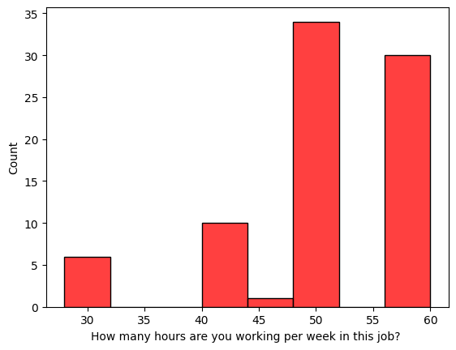

**Fig. 1 Working Hours:**

Figure 1 shows the number of hours participants work per week in their job. The highest counts are seen at 50 and 60 hours per week, suggesting a trend of extended working hours. Fewer individuals work fewer than 50 hours, with the least number working around 45 hours, indicating long work weeks are common in this group.

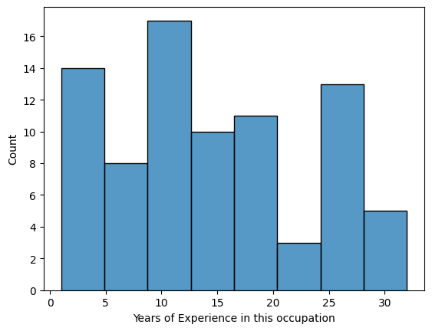

**Fig. 2 Years of Experience**

Figure 2 shows the years of experience of individuals in their occupation. Most respondents have around 10 years of experience, followed by significant counts at the early (0–5 years) and mid (25–30 years) stages. This suggests a diverse experience range with peaks at early and mid-career levels.

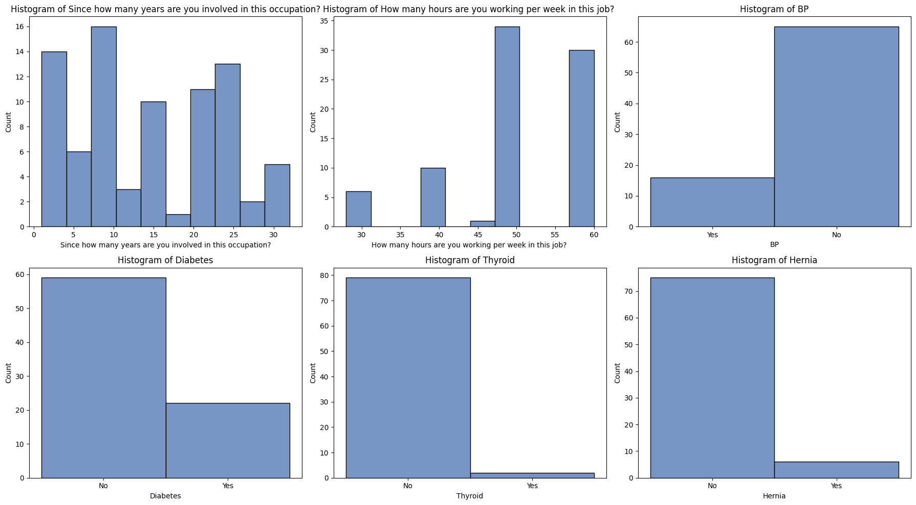

**Fig. 3 Medical History**

Figure 3 illustrates the distribution of certain health conditions among participants. A significant number of individuals reported no history of diabetes, hernia, thyroid issues, or blood pressure (BP) problems. However, a smaller yet notable portion indicated having diabetes and BP issues. Thyroid and hernia occurrences appear to be the least reported, suggesting these are less common within the group.

**Table 2- Lifestyle of the study participants**

|  |  |  |  |
| --- | --- | --- | --- |
| **Sl. No.** | **Variable** | **Category** | **N (%)** |
| 1 | Recreational Activities | Yes | 7 (8.64%) |
| No | 74 (91.36%) |
| 2 | Smoking | Yes | 17 (20.99%) |
| No | 64 (79.01%) |
| 3 | Drinking | Yes | 20 (24.69%) |
| No | 61 (75.31%) |

Table 2 presents the lifestyle characteristics of the study participants. A vast majority (91.36%) reported not engaging in recreational activities, with only 8.64% indicating participation. Regarding smoking habits, 20.99% of the participants identified as smokers, whereas 79.01% did not smoke. When it came to alcohol consumption, 24.69% of the participants reported drinking, while the remaining 75.31% abstained. These findings suggest that most participants led a lifestyle with limited recreational engagement and relatively low prevalence of smoking and drinking behaviours.

**The Rapid Upper Limb Assessment (RULA)**

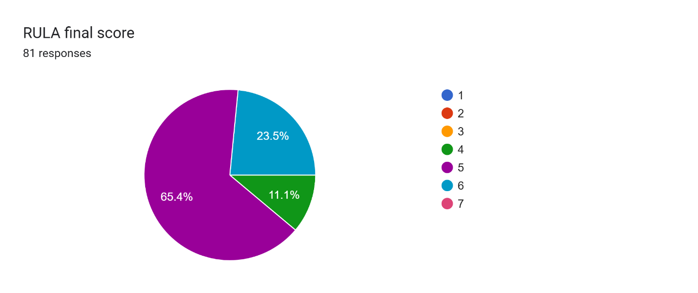

**Fig. 4) RULA Score**

**Frequency Distribution of RULA Scores**

**Table 3- RULA Final Score**

|  |  |  |
| --- | --- | --- |
| **RULA Score** | **Number of Participants** | **Percentage** |
| 4 | 9 | 11.1% |
| 5 | 52 | 64.2% |
| 6 | 20 | 24.7% |

* 76 participants (94%) were found to be in very high risk indicating need for investigation and possible ergonomic intervention (score 5 or 6).
* 9 participants (11%) were found to be in high risk indicating that they may not require immediate action but should still be monitored (score 4).
* None of the participants were found to be in the ‘acceptable’ category or ‘very high risk’ category

**Table 4 Descriptive Analysis of SF-36 Data**

|  |  |  |  |  |  |  |  |
| --- | --- | --- | --- | --- | --- | --- | --- |
| **Domain** | **Mean** | **STD.Dev** | **Min** | **25%** | **Median** | **75%** | **Max** |
| **Physical Functioning (PF)** | 67.7 | 15.5 | 35.0 | 35.0 | 75.0 | 35.0 | 95.0 |
| **Role Physical (RP)** | 69.3 | 15.0 | 33.3 | 33.3 | 66.7 | 33.3 | 83.3 |
| **Bodily Pain (BP)** | 51.4 | 39.5 | 0.0 | 0.0 | 66.7 | 0.0 | 100.0 |
| **General Health (GH)** | 45.5 | 13.3 | 20.0 | 20.0 | 46.7 | 20.0 | 80.0 |
| **Vitality (VT)** | 53.5 | 11.3 | 10.0 | 10.0 | 55.0 | 10.0 | 75.0 |
| **Social Functioning (SF)** | 67.1 | 11.7 | 35.0 | 35.0 | 70.0 | 35.0 | 90.0 |
| **Role Emotional (RE)** | 56.9 | 11.7 | 26.7 | 26.7 | 53.3 | 26.7 | 80.0 |
| **Mental Health (MH)** | 41.8 | 5.0 | 32.0 | 33.3 | 44.0 | 32.0 | 56.0 |

Based on the descriptive statistics of the SF-36 health survey data from 81 participants, we can draw several key insights into their perceived health status and quality of life: The highest mean score was observed in Role Physical (mean = 69.3), suggesting that, on average, participants report relatively high ability in fulfilling physical roles. This is closely followed by Physical Functioning (mean = 67.7) and Social Functioning (mean = 67.1), indicating that participants generally maintain a good level of physical activity and social engagement. Moderate scores are seen in Role Emotional (mean = 56.9) and Vitality (mean = 53.5), showing that while emotional roles and energy levels are somewhat affected, they are not severely compromised. The Bodily Pain score (mean = 51.4) reflects moderate pain perception, though the large standard deviation (STD.Dev = 39.5) points to wide variability among participants. General Health (mean = 45.5) and Mental Health (mean = 41.8) have the lowest mean scores, indicating lower perceived general health and psychological well-being. Notably, Mental Health also has the lowest standard deviation (5.0), implying relatively consistent but poor ratings among the population. Overall, the variability in scores across domains underscores the heterogeneity in health perceptions and experiences, suggesting a need for personalized health interventions with particular attention to mental health and general wellness.

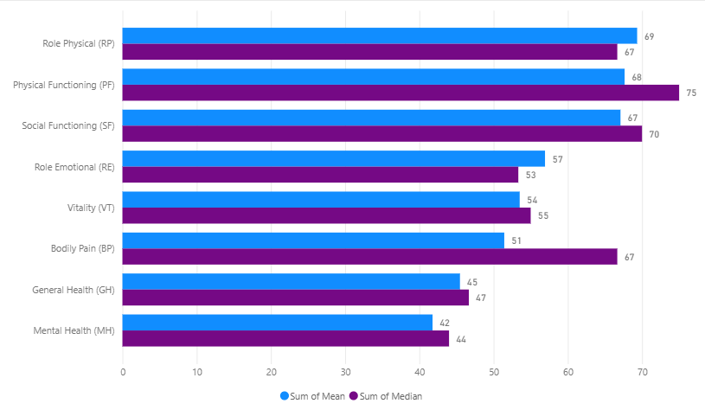

**Fig. 5: Sf-36 Mean and Median Comparison**

The bar chart compares the **mean** and **median** scores across the SF-36 health domains for 81 participants, providing insight into both average and typical experiences reported by the group.

* **Physical Functioning (PF)** has the **highest median score (75)**, indicating that a majority of participants report relatively good physical ability in performing daily tasks. Its mean score is also high (68), reflecting general consistency across the group.
* **Role Physical (RP)** and **Social Functioning (SF)** follow closely behind, with mean scores of 69 and 67, and medians of 67 and 70 respectively, suggesting strong physical role engagement and social well-being.
* **Role Emotional (RE)** and **Vitality (VT)** present **moderate values** (means ~57 and ~54, medians ~53 and ~55), indicating some emotional limitations and fluctuations in energy levels, though not severely impaired.
* **Bodily Pain (BP)** reveals a notable discrepancy: its **median score (67)** is significantly higher than the **mean (51)**, indicating a subgroup of participants experiencing substantial pain, which pulls the average down.
* **General Health (GH)** and especially **Mental Health (MH)** have the **lowest scores**. GH shows a mean of 45 and median of 47, while MH records a mean of 42 and median of 44, indicating consistently lower perceptions of overall health and mental well-being.

This visualization highlights **Physical Functioning** as the strongest domain for the group, while **Mental Health** and **General Health** emerge as the most impacted areas, reinforcing the need for targeted support and intervention in those aspects.

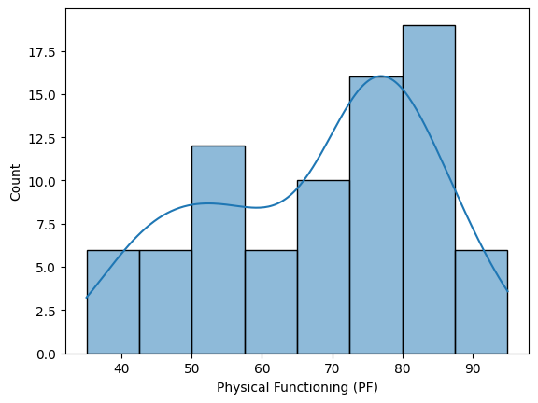 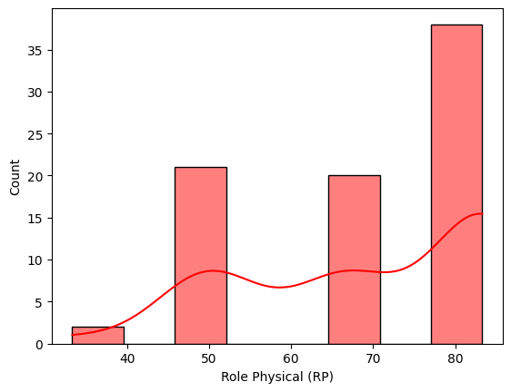

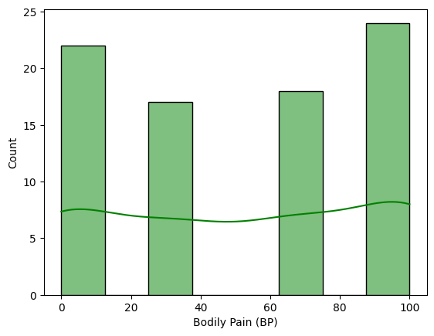 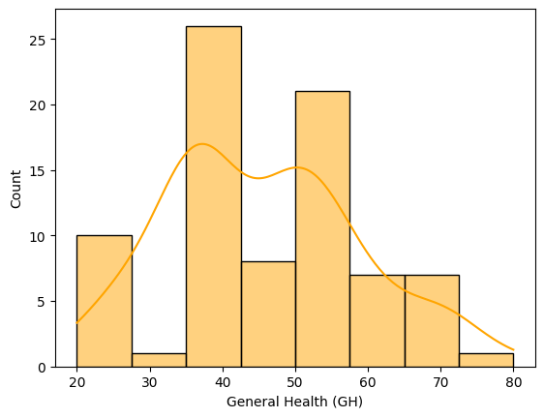

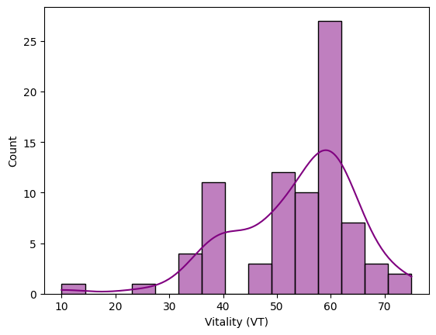 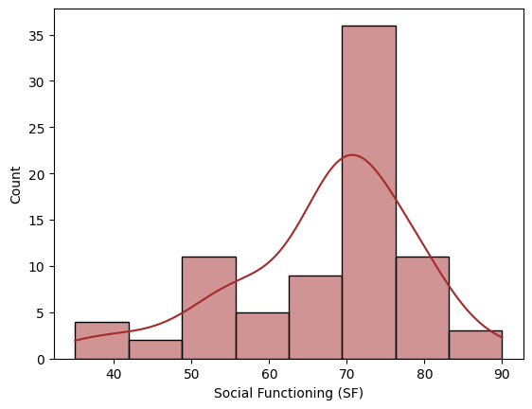

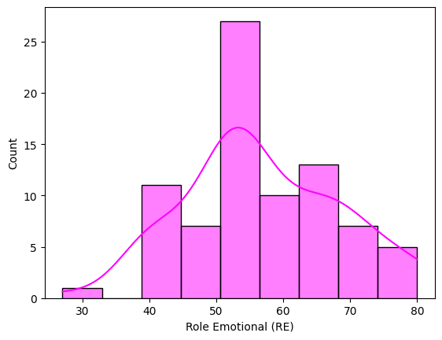 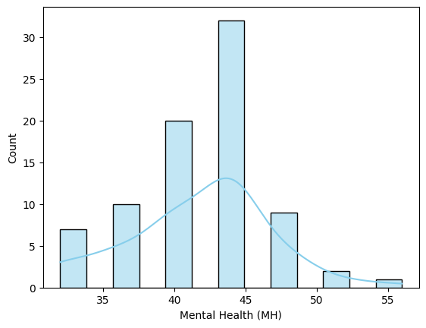

**Fig. 6 Comparison Sf-36 Domains**

The histogram plots of the SF-36 domains illustrate a mixed pattern of health perceptions among the 81 participants, revealing both strengths and areas of concern. **Physical Functioning (PF), Social Functioning (SF),** and **Role Emotional (RE)** display relatively higher concentrations toward the upper range of scores. These domains show distributions skewed slightly toward higher functioning, indicating that a significant portion of participants maintains good levels of physical capability, social interaction, and emotional role fulfilment. However, some irregularities and possible bimodal distributions suggest the existence of subgroups—some participants functioning well, while others face substantial impairments. In contrast, **Role Physical (RP)**, **Mental Health (MH),** and **Vitality (VT)** exhibit more constrained or left-skewed distributions, with many participants clustering toward the lower end of the scale. These patterns suggest more widespread difficulties with performing daily physical roles, sustaining emotional well-being, and maintaining energy levels. The **Mental Health** distribution, in particular, appears relatively narrow and skewed left, reflecting consistently lower scores and highlighting psychological distress within this population. **Bodily Pain (BP)** and **General Health (GH)** show broader, more evenly distributed patterns, indicating high variability in how participants perceive pain and general health status. This variability further supports the presence of different participants experiences and possible underlying subgroups with differing needs.

**NMQE**

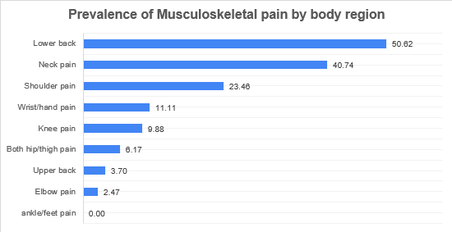

**Figure (a) Prevalence of Musculoskeletal pain by body region**

|  |  |  |  |
| --- | --- | --- | --- |
| **Region** | **Yes Count** | **No Count** | **Percentage** |
| Neck pain | 33 | 48 | 40.74 |
| Shoulder pain | 19 | 62 | 23.46 |
| Elbow pain | 2 | 79 | 2.47 |
| Wrist/hand pain | 9 | 72 | 11.11 |
| Upper back | 3 | 78 | 3.70 |
| Lower back | 41 | 40 | 50.62 |
| Both hip/thigh pain | 5 | 76 | 6.17 |
| Knee pain | 8 | 73 | 9.88 |
| ankle/feet pain | 0 | 81 | 0.00 |

**Table 8 Prevalence of musculoskeletal pain by body region**

Among the 81 participants, musculoskeletal symptoms were most prevalent in the **lower back (50.62%)**, followed by the **neck (40.74%)**, **shoulder (23.46%)**, and **knee (9.88%)** regions, indicating a notable burden of pain in areas commonly associated with posture, repetitive movements, or prolonged sitting. Moderate prevalence was observed in the **hip/thigh (6.17%)**, **upper back (3.70%)**, and **wrist/hand (11.11%)** regions, while **elbow (2.47%)** and **ankle/feet (0.00%)** pain were the least reported. These findings suggest that lower back and upper body pain are particularly common in this population, possibly due to occupational or ergonomic factors, and highlight the need for targeted preventive measures such as ergonomic interventions, posture correction, and/or ergonomic training programs.

**Association of Musculoskeletal pain compared with Physical Functioning of sf-36**

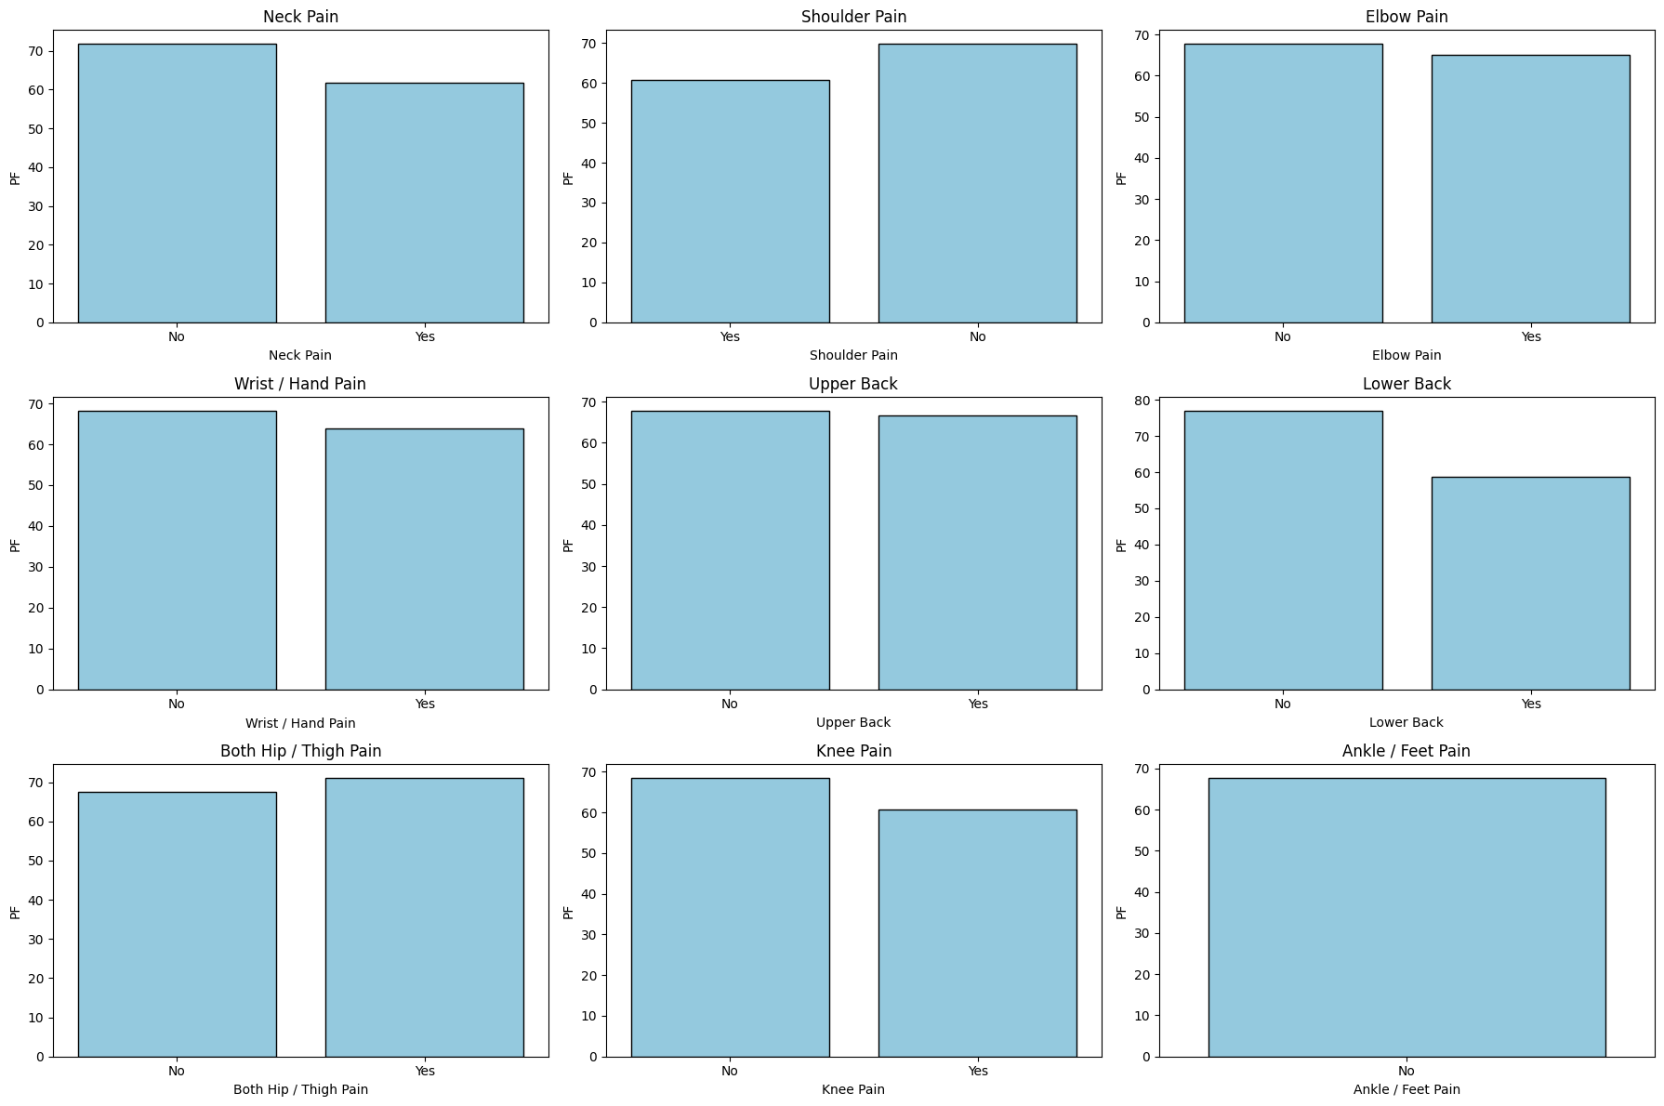







**Fig(b): Association of Sf-36 with NMQ-E**

Based on the data collected from 81 male auto drivers, a comparative analysis between SF-36 Physical Functioning (PF) scores and the prevalence of musculoskeletal pain across various body regions reveals insightful patterns. While SF-36 PF scores appear relatively similar between drivers who reported pain and those who did not in areas like the neck, shoulder, elbow, wrist/hand, upper back, and hips/thighs, a notable disparity is observed in a few specific regions.

Drivers experiencing lower back pain showed a noticeably lower PF score compared to those without pain in that region, indicating a more significant impact on their physical functioning. Similarly, knee pain was associated with a visible decrease in PF scores, though to a lesser extent. On the other hand, for ankle/feet pain, no substantial variation in PF was observed, suggesting minimal influence on overall physical functioning .These findings highlight that while musculoskeletal pain is fairly common among auto drivers, its effect on functional health varies depending on the body region involved. Lower back and knee pain seem to impair physical activity more significantly than pain in the upper limbs or extremities.

**DISCUSSION**

The present study sheds light on the multifaceted burden of musculoskeletal disorders (MSDs) among auto drivers in Chennai, Tamil Nadu, through the integration of SF-36 health-related quality of life data, regional pain prevalence based on the Nordic Musculoskeletal Questionnaire-Extended (NMQ-E), and postural risk evaluation using the Rapid Upper Limb Assessment (RULA). This triangulated approach allows for a nuanced understanding of both the physical and psychological dimensions of occupational health in this underserved population.

**Health-Related Quality of Life (SF-36)**

The SF-36 health survey revealed several key patterns across its domains. The **Physical Functioning (PF)** domain exhibited comparatively higher mean scores, suggesting that many drivers retained the capacity to perform basic physical tasks. However, the **Role Physical (RP)** domain recorded among the **lowest scores**, indicating that physical health significantly interfered with daily responsibilities, such as prolonged driving, load handling, and maintenance work. This discrepancy between functional ability and role performance underscores the hidden toll of physical strain that often goes unnoticed until it impairs occupational productivity.

The domains of **Vitality (VT)** and **Mental Health (MH)** showed moderate to low scores, pointing toward persistent fatigue, low energy levels, and symptoms indicative of anxiety or depression. These findings align with broader studies that link chronic physical stress with emotional disturbances, particularly in professions characterized by isolation, long hours, and unpredictable workloads—such as auto driving.

Interestingly, **Social Functioning (SF)** and **Role Emotional (RE)** presented relatively higher means but also wide variability, as evidenced by large standard deviations. This suggests heterogeneity in how individuals manage emotional and interpersonal challenges. Factors such as family support, resilience, personality traits, and access to healthcare may influence this disparity.

The **Bodily Pain (BP)** and **General Health (GH)** domains showed moderate averages with wide score distributions, again emphasizing variability in subjective health perception. Some individuals appeared to manage pain and stress well, while others reported significantly diminished health status. These results reinforce the importance of personalized and context-aware healthcare strategies for occupational groups.

**Prevalence and Regional Distribution of Musculoskeletal Pain (NMQ-E)**

The prevalence data from the NMQ-E questionnaire offered deeper insight into specific anatomical regions affected by musculoskeletal discomfort. The most affected area was the **lower back**, with **50.62%** of drivers reporting pain, followed by the **neck** (40.74%). These two regions, forming the spinal axis, are particularly vulnerable due to prolonged static sitting, lack of ergonomic support, and exposure to vehicle vibration. These findings echo global patterns observed among drivers and reinforce the importance of lumbar support cushions, adjustable seating, and scheduled rest breaks.

Other affected regions included:

* **Shoulder pain** in **23.46%** of drivers, likely due to steering activities, arm elevation, or gear shifting without ergonomic aid.
* **Wrist/hand pain** reported by **11.11%**, possibly from repetitive use of controls, poor wrist alignment, and excessive gripping.
* **Knee pain** in **9.88%**, reflecting stress from pedal use, restricted legroom, and prolonged immobility.
* **Hip/thigh pain** in **6.17%**, attributed to compressed posture, lack of seat cushioning, or lateral stress during manual driving.
* **Upper back pain** (**3.70%**) and **elbow pain** (**2.47%**) were less common, but still noteworthy.
* **Ankle/feet pain** was not reported (0.00%), which could indicate limited or virtually no repetitive ankle movement, and sufficient legroom for this population.

The relatively lower prevalence of pain in some regions does not necessarily mean absence of risk but could reflect differences in usage patterns, pain thresholds, or awareness.

**Postural Risk Analysis Using RULA**

The **Rapid Upper Limb Assessment (RULA)** tool was applied to evaluate the ergonomic risk factors related to posture and upper body stress during driving and associated tasks (e.g., vehicle maintenance, loading/unloading). The RULA results revealed that a significant proportion of the drivers fell into **Action Level 3 (investigation and change soon required)** and **Action Level 4 (immediate investigation and change required)**.

Key findings from RULA include:

* **Neck flexion** and **forward head posture** were common, increasing strain on the cervical spine and contributing to neck and shoulder pain.
* **Static upper arm elevation** and **elbow flexion** were frequently observed during prolonged gripping of the steering wheel, contributing to upper limb discomfort and fatigue.
* **Trunk bending and twisting** were observed during entry/exit from the vehicle and during luggage handling, increasing the risk of lower back and hip strain.
* **Wrist deviations** were frequent, especially in older vehicle models with stiff gear mechanisms, increasing the risk of carpal tunnel and wrist tendonitis.

The **RULA scoring** confirmed that most participants operate under **medium to high ergonomic risk**, reinforcing the need for immediate intervention. In particular, the static nature of the job, lack of movement breaks, and substandard cab designs contribute to postural overload. Furthermore, the absence of ergonomic training among drivers aggravates the problem, as most are unaware of safe postures and injury-prevention techniques.

The integrated analysis across SF-36, NMQ-E, and RULA offers a comprehensive picture of how **ergonomic strain, psychological distress, and physical limitations intersect** to influence health outcomes among auto drivers.

**LIMITATIONS**

**Limitation:**

* The cross-sectional design of the study limits the ability to establish causal relationships between ergonomic risk factors and musculoskeletal disorders.
* The sample size of 81 auto drivers, while suitable for preliminary analysis, may not represent the broader auto driver population across different regions or work environments.
* The study relied on self-reported data through questionnaires like SF-36 and NMQ-E, which may be affected by recall bias or underreporting, especially in areas like pain perception and mental health.
* The research was conducted only in Chennai, which limits the generalizability of the findings to other geographic or urban populations with different working conditions.
* Confounding factors such as pre-existing health conditions, individual pain tolerance, and lifestyle behaviours (e.g., physical activity, smoking) were not deeply controlled, which may have influenced the outcomes.
* There is a need for future studies with:
  + Longitudinal designs
  + Larger sample sizes
  + Multi-regional comparisons  
    to validate and expand upon the current findings.

**RECOMMENDATIONS**

**Recommendation**

To improve the quality of life and reduce the risk of musculoskeletal disorders among auto drivers in Chennai, the following recommendations are proposed:

1. **Posture training**
   * Educate drivers on proper sitting posture and ergonomics during long hours of driving.
   * Encourage the use of seat cushions or lumbar support to maintain spinal alignment.
   * Promote short breaks every 1–2 hours to stretch and reduce stiffness.
   * Regular workshops on posture correction and safe driving techniques.
2. **Regular Physical Exercise**
   * Advocate for simple daily exercises such as stretching, walking, or yoga to enhance flexibility and reduce muscle fatigue.
   * Community-based fitness programs or morning group sessions can be introduced to encourage consistency.
   * Simple stretching routines to be performed before and after driving sessions.
3. **Awareness and Training Programs**
   * Conduct workshops or awareness drives focused on health education, safe driving practices, and ergonomic principles.Provide printed guides or visual aids in local language (Tamil) for better understanding and retention
4. **Ergonomic Interventions**:
   * Provision of adjustable seats with lumbar support.
   * Use of steering wheel covers and ergonomic grips to reduce upper limb strain.
   * Modifications in pedal layout to support natural leg posture.
   * Use of seat vibration-damping technologies.
5. **Mental Health Support**:
   * Access to counselling services and stress management sessions.
   * Development of peer-support networks to reduce isolation and emotional burden.
6. **Healthy Lifestyle Practices**
   * Raise awareness about the harmful effects of smoking and alcohol on overall health, especially on the musculoskeletal and cardiovascular systems.
   * Provide access to counselling or support groups aimed at reducing or quitting these habits.
7. **Regular Health Checkups**
   * Encourage annual or biannual health check-ups, including physical, orthopedic, and mental health screenings.
   * Collaborate with local clinics or health camps to offer affordable or free health assessments.
8. **Policy-Level Advocacy**:
   * Enforcement of work-hour limitations and rest break mandates.
   * Subsidies for ergonomic seat upgrades in older vehicles.
   * Inclusion of drivers in occupational health surveillance programs.
9. **Further Research**:
   * Longitudinal studies to assess the progression of MSDs.
   * Analysis of how variables like age, years of experience, and vehicle type influence risk.

**CONCLUSION**

**Conclusion:**

This study highlights the significant burden of musculoskeletal disorders among auto drivers in Chennai, with a particularly high prevalence of lower back (50.62%) and neck pain (40.74%). The SF-36 data illustrates how these physical challenges are compounded by reductions in mental health and role functioning, reflecting a deeply interconnected relationship between occupational strain and overall well-being. The RULA assessment further reveals that most drivers operate under unsafe postural conditions that warrant urgent ergonomic correction. In conclusion, the findings underscore the urgent need for multi-dimensional interventions including ergonomic redesign, health education, mental health support, and regular screening to improve the quality of life and work sustainability for auto drivers. Ensuring occupational safety in informal sectors like auto driving is not only a public health imperative but also a step toward social equity and economic resilience in semi-urban and rural India.

**REFERENCES**

1. Nafeesa MAC, Vidhya Venugopal, Vijayalakshmi P, **Rajkumar P***Perceived work-related psychosocial stress and musculoskeletal disorder complaints among call centre workers in India – A cross-sectional study* Annals of Musculoskeletal Disorders. 1 (1): 1005
2. Sandul Yasobant, **Paramasivan Rajkumar** *Health of the healthcare professionals: A risk assessment study on work-related musculoskeletal disorders in a tertiary hospital, Chennai, India.* International Journal of Medicine and Public Health. Vol 5 Iss 2 Apr-Jun 2015, pp. 189-195 ISSN: Online 2230-8598
3. Sandul Yasobant, **Paramasivan Rajkumar** *Work-related musculoskeletal disorders among health care professionals: A cross-sectional assessment of risk factors in a tertiary hospital, India.* Indian Journal of Occupational & Environmental Medicine. Vol 18 Iss 2 May-Aug 2014, pp. 75-81 ISSN 0973-2284
4. Benjamin F. Arnold, Ranjiv S. Khush, Padmavathi Ramaswamy, **Paramasivan Rajkumar**, Natesan Durairaj, Prabhakar Ramaprabha, Kalpana Balakrishnan, and John M. Colford Jr. *Short Report: Reactivity in Rapidly Collected Hygiene and Toilet Spot Check Measurements: A Cautionary Note for Longitudinal Studies.* Am. J. Trop. Med. Hyg. 92(1), 2015, pp. 159-162 doi:10.4269/ajtmh.14-0306
5. Ranjiv Khush, Benjamin F. Arnold, Padma Srikanth, Suchithra Sudharsanam, Padmavathi Ramaswamy, Natesan Durairaj, Alicia G. London, Prabhakar Ramaprabha, **Paramasivan Rajkumar**, Kalpana Balakrishnan, and John M. Colford Jr. *H2S as an Indicator of Water Supply Vulnerability and Health Risk in Low-Resource Settings: A Prospective Cohort Study.* Am. J. Trop. Med. Hyg., 89(2), 2013, pp. 251-259 doi:10.4269/ajtmh.13-0067
6. Benjamin F. Arnold, Ranjiv S. Khush, Padmavathi Ramaswamy, Alicia G. London, **Paramasivan Rajkumar**, Prabhakar Ramaprabha, Natesan Durairaj, Alan E. Hubbard, Kalpana Balakrishnan and John M. Colford, Jr.*Causal inference methods to study non-randomized, pre-existing development interventions*. PNAS, Volume 107 (December 28, 2010), No. 52, Pg: 22605-22610
7. Ramalingam Ayyappan, Sambandam Sankar, Paramasivan Rajkumar, Kalpana Balakrishnan *Work-related heat stress concerns in automotive industries: a case study from Chennai, India. Heat, Work and Health: Implications of Climate Change.* Global Health Action, Volume 2 (November 2009), Pg: 58-64
8. RULA (Rapid Upper Limb Assessment) Original Paper Reference: McAtamney, L., & Corlett, E. N. (1993). RULA: a survey method for the investigation of work-related upper limb disorders. Applied Ergonomics, 24(2), 91-99. DOI: 10.1016/0003-6870(93)90080-S
9. SF-36 (36-Item Short Form Health Survey) Original Paper Reference: Ware, J. E., Jr., & Sherbourne, C. D. (1992). The MOS 36-item short-form health survey (SF-36): I. Conceptual framework and item selection. Medical Care, 30(6), 473-483. DOI: 10.1097/00005650-199206000-00002
10. Zhang, L., & Li, Z. (2023). *Prevalence and Risk Factors for Musculoskeletal Disorders Among Truck Drivers: A Systematic Review*. *Journal of Occupational Health*, 65(4), 217-228.
11. Lundberg, A., & Ohlsson, K. (1998). *Work-related musculoskeletal disorders in long-haul truck drivers: A longitudinal study of the impact on health and job satisfaction.* Scandinavian Journal of Work, Environment & Health, 24(5), 347-354.
12. Hébert, J. R., & Croteau, P. (2016). *The impact of musculoskeletal disorders on the quality of life of long-haul truck drivers: A systematic review.* Occupational Health Psychology, 21(2), 185-198.
13. Bovenzi, M., & Sorrentino, S. (2003). *Health effects of vibration exposure: A review of recent studies.* International Archives of Occupational and Environmental Health, 76(4), 265-275.
14. Hébert, J. R., & Croteau, P. (2016). *The impact of musculoskeletal disorders on the quality of life of long-haul truck drivers: A systematic review.* Occupational Health Psychology, 21(2), 185-198
15. Apostolopoulos, Y., Sonmez, S., Shattell, M., & Belzer, M. (2016). Worksite-induced morbidities among truck drivers in the United States. AAOHN Journal, 64(7), 285-296.
16. Bovenzi, M. (2006). Health risks from occupational exposures to mechanical vibration. Medicina del Lavoro, 97(3), 535-541.
17. Certainly! Here are four scholarly references focusing on the health and occupational challenges faced by auto-rickshaw drivers in India, formatted similarly to the examples you provided:
18. Singh, L. P. (2019). Musculoskeletal Disorders and Whole Body Vibration Exposure among Auto-Rickshaw (Three Wheelers) Drivers: A Case Study in Northern India. Ergonomics International Journal, 3(3), 000206.
19. Chaudhary, L. (2020). Prevalence of Occupational Health Disorders in Auto Rickshaw Drivers. Indian Journal of Physiotherapy and Occupational Therapy, 14(3), 80–84.
20. Waingankar, P., & Waingankar, S. (2018). Cross-sectional Study of Health Status of Auto Rickshaw Drivers in Vashi, Navi Mumbai, India. International Journal of Community Medicine and Public Health, 5(3), 1040–1044.
21. Islam, K. R., & Islam, M. S. (2019). Health Related Factors and Disability of Auto Rickshaw Drivers in Dhaka City. IOSR Journal of Dental and Medical Sciences, 18(1), 30–37.

**ANNEXURE**

**ANNEXURE - 1**

**INFORMED CONSENT**

**Study Title**

*“Prevalence of musculoskeletal disorders among auto drivers and their association with ergonomic risk factor and quality of life in chennai”*

**Introduction**

You are being invited to participate in a research study conducted by Sanjay. N from Sri Ramachandra Institute of Higher education and Research. Before you decide, it is important that you understand why this research is being done and what it will involve. Please read the following information carefully and ask questions if anything is unclear.

**Purpose of the Study**

Musculoskeletal disorders (MSDs) are one of the most important and common occupational health problems in the working population. MSDs affect the body's muscles, joints, ligaments, tendons, and nerves.

The study aims to identify ergonomic risk factors related to auto driving and their impact on the health of auto drivers. This information will help design better strategies to improve the occupational health and safety of auto drivers.

**What Participation Involves**

1. **Duration**: The study was taken approximately 20–30 minutes of your time.
2. **Activities**: You will be asked to:
   * Complete a questionnaire about your work environment, health, and lifestyle.
   * Allow researchers to observe your posture and vehicle ergonomics.
   * Participate in basic health measurements (e.g., height, weight, blood pressure), if applicable.

**Voluntary Participation**

Participation in this study is completely voluntary. You are free to decline participation or withdraw at any time without any consequences or loss of benefits.

**Potential Risks and Discomforts**

There are no significant risks associated with this study. You may experience minor discomfort while answering questions or during posture observation, but these will be brief.

**Benefits of Participation**

While there are no direct benefits to you, the study’s findings may contribute to improving working conditions and health outcomes for Auto drivers in the future.

**Confidentiality**

Your information will remain confidential and will only be used for research purposes. Data will be stored securely, and your identity will not be disclosed in any reports or publications.

**Contact Information**

If you have any questions about the study or your participation, please contact:  
Sanjay.N  
Sri Ramachandra Institute of Higher Education and Research

6382589027  
[sanjayjeja@gmail.com](mailto:sanjayjeja@gmail.com)

**Consent Declaration**

* I have read and understood the information provided.
* I have had the opportunity to ask questions, and my questions have been answered to my satisfaction.
* I understand that participation is voluntary and that I can withdraw at any time without giving a reason.
* I agree to participate in this study.

**Participant’s Name**: ____________________________  
**Signature**: ____________________________  
**Date**: ____________________________

**Researcher’s Name**: ____________________________  
**Signature**: ____________________________  
**Date**: ____________________________

This form ensures ethical compliance and respects the rights and autonomy of participants.

**தெரிவிக்கப்பட்ட ஒப்புதல்**

**ஆய்வு தலைப்பு**

*“ஆட்டோ ஓட்டுநர்களிடையே தசைக்கூட்டு கோளாறுகளின் பரவல் மற்றும் பணிச்சூழலியல் ஆபத்து காரணிகள் மற்றும் வாழ்க்கைத் தரத்துடன் அவற்றின் தொடர்பு”*

**அறிமுகம்**

நீங்கள் சஞ்சய்.ந அவர்களால் நடத்தப்படும் ஒரு ஆராய்ச்சி திட்டத்தில் கலந்து கொள்ள அழைக்கப்படுகிறீர்கள். இதில் பங்கேற்க முன், இந்த ஆராய்ச்சி எதற்காக நடத்தப்படுகிறது மற்றும் இதில் நீங்கள் எதைச் செய்ய வேண்டும் என்பதைக் கவனமாகப் படித்து, தேவையான சந்தேகங்களை கேளுங்கள்.

**ஆய்வின் நோக்கம்**

தசைக்கூட்டு கோளாறுகள் ( MSDs) உழைக்கும் மக்களில் மிக முக்கியமான மற்றும் பொதுவான தொழில்சார் சுகாதார பிரச்சனைகளில் ஒன்று. MSDs உடல் தசைகள், மூட்டுகள், தசைநார்கள், தசைநார்கள், மற்றும் நரம்புகள் பாதிக்கும்.

இந்த ஆய்வு ஆட்டோ ஓட்டுநர்களின் உடல் அமைப்பு சம்பந்தமான அபாயக் காரணங்களை மற்றும் அவை அவர்களின் உடல் நலத்துடன் தொடர்புபட்டுள்ளதைக் கண்டறிவதை நோக்கமாகக் கொண்டுள்ளது. இதனால் ஆட்டோ ஓட்டுநர்களின் தொழில்சார் உடல் நலத்தை மேம்படுத்த உதவிக்கரமாக இருக்கும் புதிய திட்டங்களை உருவாக்க முடியும்.

**பங்கேற்பில் சேருவது என்னென்ன அடங்கும்**

1. **காலநிலை**: இந்த ஆய்வில் பங்கேற்பது உங்கள் 20-30 நிமிடங்களை எடுக்கும்.
2. **செயல்கள்**:
   * உங்கள் வேலை சூழல், உடல் நலம் மற்றும் வாழ்க்கை முறை தொடர்பான கேள்வித்தாளை நிரப்ப வேண்டும்.
   * உங்கள் உடல் நிலையை (நிலைகூறல்) மற்றும் வாகன அமைப்பை ஆய்வாளர்கள் கவனிக்க அனுமதிக்க வேண்டும்.
   * அடிப்படை உடல் அளவீடுகளில் (எ.கா., உயரம், எடை, இரத்த அழுத்தம்) பங்கேற்க வேண்டும் (தேவைப்பட்டால்).

**தன்னார்வ பங்கேற்பு**

இந்த ஆய்வில் பங்கேற்பது முற்றிலும் தன்னார்வமாகும். பங்கேற்பதற்கோ, பங்கேற்பதை நிறுத்திக்கொள்ளவதற்கோ, உங்கள் விருப்பத்தை நீங்கள் எப்போது வேண்டுமானாலும் தெரிவிக்கலாம்.

**அபாயங்கள் மற்றும் அசௌகரியங்கள்**

இந்த ஆய்வுடன் தொடர்புடைய பெரிய அபாயங்கள் எதுவும் இல்லை. நீங்கள் கேள்விகளைப் பதிலளிக்கும்போதோ அல்லது நிலைகூறல் ஆய்வின் போது சிறிய அளவிலான அசௌகரியங்களை எதிர்கொள்ளலாம், ஆனால் அவை குறுகிய காலமாகவே இருக்கும்.

**பங்கேற்பின் நன்மைகள்**

இந்த ஆய்வு உங்கள் உடல் நலத்திற்கு நேரடி நன்மைகளை அளிக்கவில்லை, ஆனால் இதன் முடிவுகள் ஆட்டோ ஓட்டுநர்களின் வேலை நிலை மற்றும் உடல் நலத்தை மேம்படுத்த உதவலாம்.

**ரகசியத்தன்மை**

உங்கள் தகவல்கள் ரகசியமாக பராமரிக்கப்படும் மற்றும் ஆராய்ச்சி நோக்கங்களுக்கே பயன்படுத்தப்படும். தரவுகள் பாதுகாப்பாக சேமிக்கப்படும், மேலும் எந்த அறிக்கைகளிலோ அல்லது வெளியீடுகளிலோ உங்கள் அடையாளம் வெளிப்படுத்தப்படாது.

**தொடர்பு தகவல்கள்**

இந்த ஆய்வைப் பற்றி அல்லது இதில் உங்கள் பங்கேற்பைப் பற்றி கேள்விகள் இருந்தால், தயவுசெய்து தொடர்பு கொள்ளுங்கள்:  
சஞ்சய்.ந

ஸ்ரீ ராமச்சந்திரா உயர் கல்வி மற்றும் ஆராய்ச்சி நிறுவனம்

6382589027  
sanjayjeja@gmail.com

**ஒப்புதல் அறிக்கை**

* எனக்கு வழங்கப்பட்ட தகவல்களை நான் படித்து, புரிந்துகொண்டேன்.
* என்னுடைய சந்தேகங்களை கேட்கும் வாய்ப்பு எனக்கு அளிக்கப்பட்டது, மேலும் எனது சந்தேகங்களுக்கு திருப்திகரமான பதில்கள் கிடைத்தன.
* பங்கேற்பு விருப்பத்திற்கேற்பம் என்பதை நான் அறிவிருக்கிறேன் மற்றும் எந்த நேரத்திலும் காரணம் கூறாமல் விலகக்கூடிய உரிமை எனக்கு உண்டு.
* நான் இந்த ஆய்வில் பங்கேற்க ஒப்புக்கொள்கிறேன்.

**பங்கேற்பாளரின் பெயர்**: ____________________________  
**கையொப்பம்**: ____________________________  
**தேதி**: ____________________________

**ஆய்வாளரின் பெயர்**: ____________________________  
**கையொப்பம்**: ____________________________  
**தேதி**: ____________________________

இந்தப் படிவம் பங்கேற்பாளர்களின் உரிமைகளையும் சுதந்திரத்தையும் மதித்து, நெறிமுறைகளுக்கு இணங்க ஆய்வை நடத்த உதவும்

**ANNEXURE - 2**

General Questionnaire

1. Personal Details:
2. ID : ________________
3. Age (Y) : ________________
4. Sex : ________________
5. Height : _____________m
6. Weight : _____________kg
7. Marital status: _____________
8. Occupational History & Details:
9. Give your - a) Job Designation ________________ b) Level ________________
10. Since how many years are you working in this organization? ___________________
11. Since how many years are you involved in this occupation? _________________
12. How many hours are you working per week in this job? _____________
13. In your job, which of the following posture(s) do you have to assume for *uncomfortably long periods of time*? [Put a ‘Tick’ mark against all that is applicable]
    1. Forward bending of neck
    2. Backward bending of neck
    3. Working with raised arms
    4. Forward bending (stooping) of trunk
    5. Side bending of trunk
    6. Twisting your trunk
    7. Prolonged sitting
    8. Prolonged standing
    9. Writing / using your fingers
    10. Others (specify) _________________________
14. Medical History:
15. Give details of any past / present medical illness
    1. Condition __________
    2. Duration _______ (Y / M)
16. Give details of any medication that you are taking
    1. Medicine __________
    2. Duration _______ (Y / M)
17. Have you ever been diagnosed with any musculoskeletal condition / fracture? If yes,
    1. Condition ___________
    2. Duration _______ (Y / M)
18. Are you suffering from musculoskeletal pain/ discomfort now? If yes,
    1. Problem ______________
    2. Duration _______ (Y / M)
19. Do the current musculoskeletal symptoms (pain/discomfort)
    1. Increase during working days? _______________
    2. Increase by the end of work shift? ____________
    3. Decrease during holidays? ______________
20. In order to overcome your current musculoskeletal symptoms, are you
    1. Taking any treatment? If yes, details ___________________
    2. Following any coping strategy (on your own)? If yes, details _________________
21. Lifestyle & Habits:
22. Are you a Vegetarian or Non vegetarian? ______________________

19. Do you involve yourself in any recreational activities / exercises / yoga / …..? If yes,

Give details __________________with *duration* ____ hours and *frequency* _____/week

20.Give details of your smoking / drinking (alcohol) habits, *if applicable* – Current / Past

[Put a ‘Tick’ mark appropriately against the ‘habit’ as well as the ‘timing’]

**The Rapid Upper Limb Assessment (RULA)**

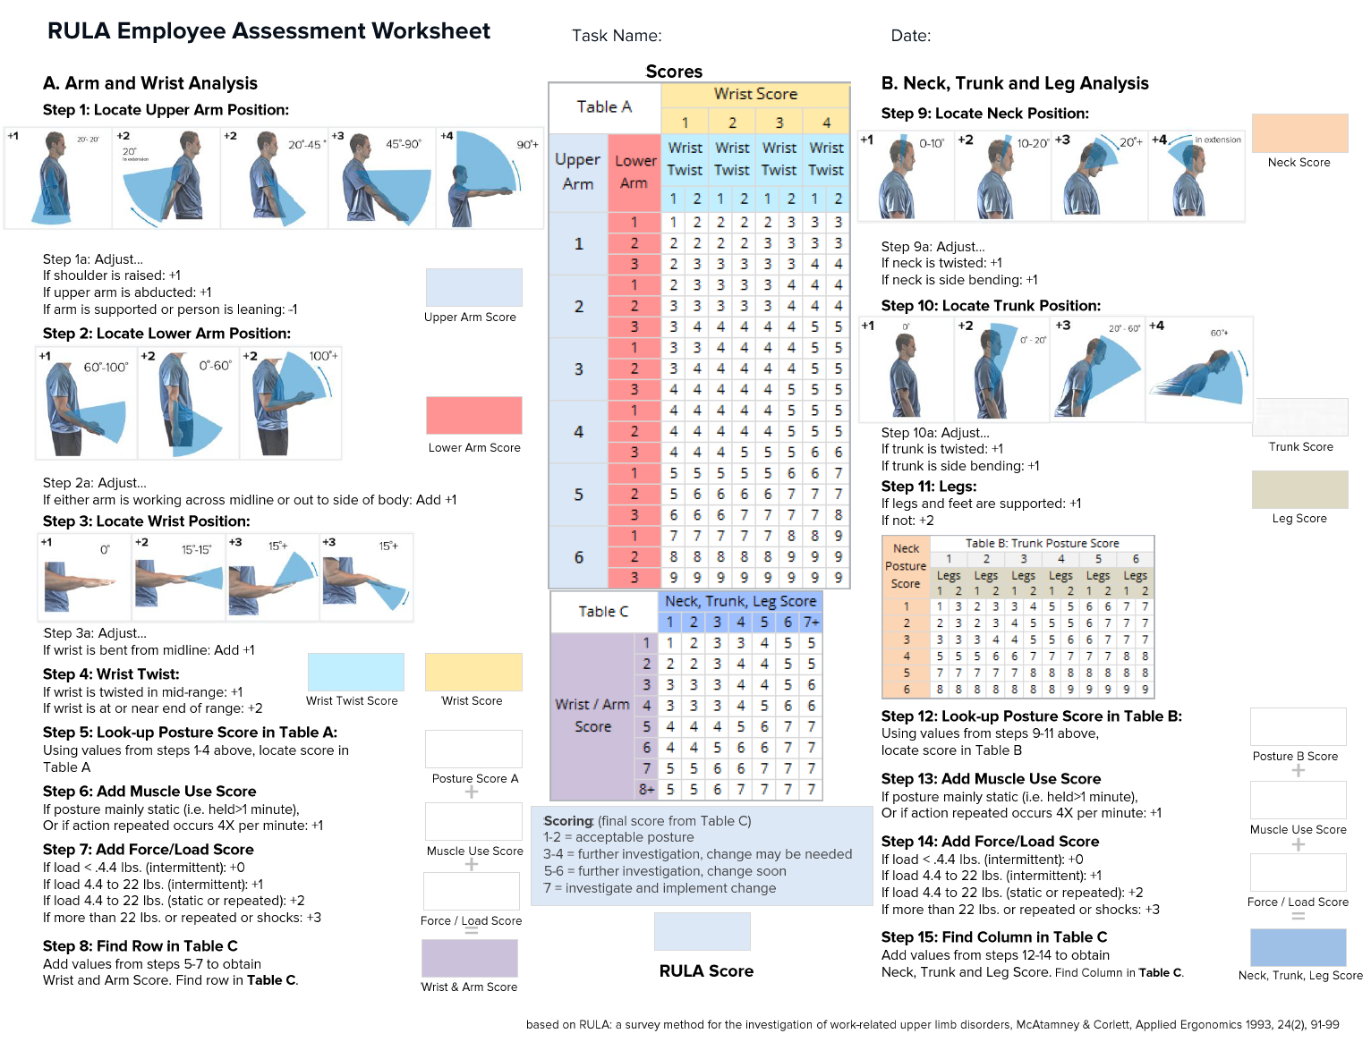

It is a widely recognized ergonomic tool to evaluate the risk of WMSDs. Developed by Dr. Lynn McAtamney and Professor E. Nigel Corlett at the University of Nottingham, RULA provides a systematic approach to assessing postural risks associated with various occupational tasks. RULA analyze specific body regions namely the upper arms, lower arms, wrists, neck, trunk, and legs during task performance. Each body part is scored based on its position. These individual scores are then combined using a scoring matrix to produce a final RULA score ranging from 1 to 7. A higher score indicates a greater risk of and a more urgent need for intervention. Specifically, scores of 1–2 suggest that the posture is acceptable if not maintained or repeated for long periods; 3–4 indicate that further investigation is needed; 5–6 signify those changes are required soon; and a score of 7 necessitates immediate action

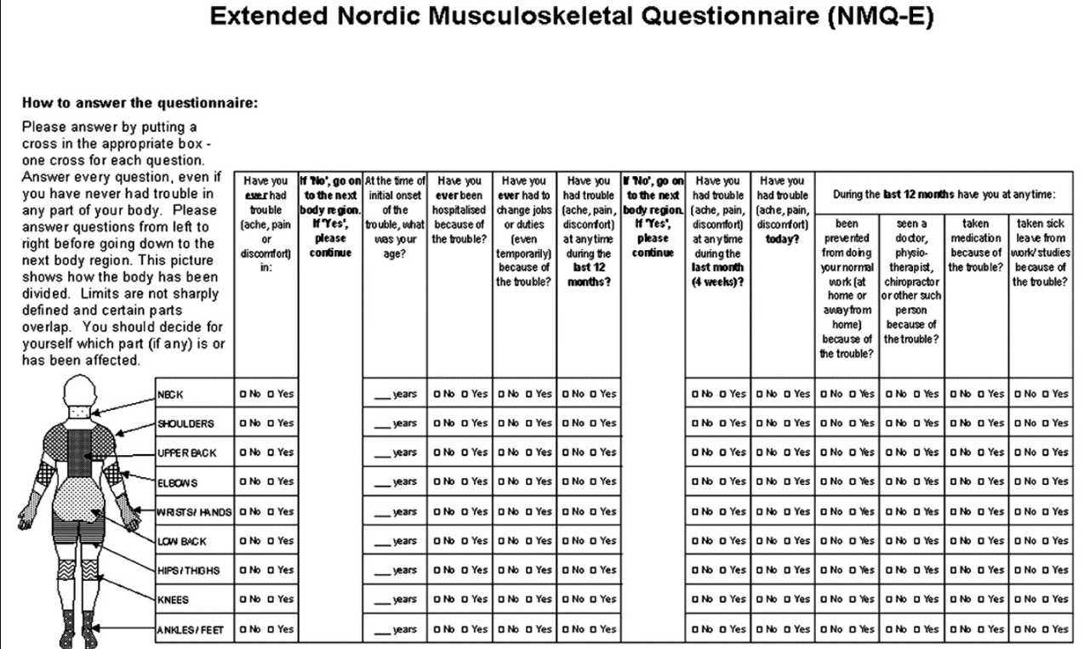

The Extended Nordic Musculoskeletal Questionnaire (NMQ-E) is a standardized tool used to assess musculoskeletal symptoms in various body regions. It captures data on pain, discomfort, and functional limitations over different timeframes (e.g., 12 months, 4 weeks, today). The questionnaire also explores the impact of symptoms on work, healthcare usage, and daily functioning. It is widely used in ergonomic and occupational health research to identify risk-prone body areas and related health outcomes.

**SF 36 Questionnaire.**

**Choose one option for each questionnaire item.**

1. In general, would you say your health is:

1 – Excellent 2 - Very good 3 – Good 4 – Fair 5 - Poor

2. Compared to one year ago, how would you rate your health in general now?

1. Much better now than one year ago 2. Somewhat better now than one year ago

3. About the same 4. Somewhat worse now than one year ago 5. Much worse now than one year ago

|  |  |  |  |
| --- | --- | --- | --- |
| The following items are about activities you might do during a typical day. Does your  health now limit you in these activities? If so, how much? | Yes, limited a lot | Yes, limited a little | No, not limited at all |
| 3. Vigorous activities, such as running, lifting heavy objects, participating in strenuous sports |  |  |  |
| 4. Moderate activities, such as moving a table, pushing a vacuum cleaner, bowling, or playing golf |  |  |  |
| 5. Lifting or carrying groceries |  |  |  |
| 6. Climbing several flights of stairs |  |  |  |
| 7. Climbing one flight of stairs |  |  |  |
| 8. Bending, kneeling, or stooping |  |  |  |
| 9. Walking more than a mile |  |  |  |
| 10. Walking several blocks |  |  |  |
| 11. Walking one block |  |  |  |
| 12.Bathing or dressing yourself |  |  |  |

|  |  |  |
| --- | --- | --- |
| During the past 4 weeks, have you had any of the following problems with your work or other regular daily activities as a result of your physical health? | Yes | NO |
| 13. Cut down the amount of time you spent on work or other activities |  |  |
| 14. Accomplished less than you would like |  |  |
| 15. Were limited in the kind of work or other activities |  |  |
| 16. Had difficulty performing the work or other activities (for example , it took extra effort) |  |  |

|  |  |  |
| --- | --- | --- |
| During the past 4 weeks, have you had any of the following problems with your work or other regular daily activities as a result of any emotional problems (such as feeling depressed or anxious)? | Yes | NO |
| 17. Cut down the amount of time you spent on work or other activities |  |  |
| 18. Accomplished less than you would like |  |  |
| 19. Didn't do work or other activities as carefully as usual |  |  |
| 16. Had difficulty performing the work or other activities (for example, it took extra effort) |  |  |

20. During the past 4 weeks, to what extent has your physical health or emotional problems interfered with your normal social activities with family, friends, neighbors, or groups?

 1. Not at all  2. Slightly  3. Moderately   4.Quite a bit   5.Extremely

21. How much bodily pain have you had during the past 4 weeks?

 1. None  2. Very mild  3. Mild   4. Moderate  5. Severe  6. Very severe

22. During the past 4 weeks, how much did pain interfere with your normal work (including both work outside the home and housework)?

1. Not at all  2. A little bit  3. Moderately  4. Quite a bit  5. Extremely

|  |  |  |  |  |  |  |
| --- | --- | --- | --- | --- | --- | --- |
| These questions are about how you feel and how things have been with you during the past 4 weeks. For each question, please give the one answer that comes closest to the way you have been feeling.  How much of the time during the past 4 weeks... | All of  the  time | Most of the time | A good bit of the time | Some of the time | A little of the time | None of the time |
| 23. Did you feel full of pep? |  |  |  |  |  |  |
| 24. Have you been a very nervous person? |  |  |  |  |  |  |
| 25. Have you felt so down in the dumps that nothing could cheer you up? |  |  |  |  |  |  |
| 26. Have you felt calm and peaceful? |  |  |  |  |  |  |
| 27. Did you have a lot of energy? |  |  |  |  |  |  |
| 28. Have you felt downhearted and blue? |  |  |  |  |  |  |
| 29. Did you feel worn out? |  |  |  |  |  |  |
| 30. Have you been a happy person? |  |  |  |  |  |  |
| 31. Did you feel tired? |  |  |  |  |  |  |

32. During the past 4 weeks, how much of the time has your physical health or emotional problems interfered with your social activities (like visiting with friends, relatives, etc.)?

1. All of the time  2.Most of the time  3. Some of the time 4. A little of the time  5. None of the time

|  |  |  |  |  |  |
| --- | --- | --- | --- | --- | --- |
| How TRUE or FALSE is each of the following   statements for you. | Definitely true | Mostly true | Don't know | Mostly false | Definitely false |
| 33. I seem to get sick a little easier than other people |  |  |  |  |  |
| 34. I am as healthy as anybody I know |  |  |  |  |  |
| 35. I expect my health to get worse |  |  |  |  |  |
| 36. My health is excellent |  |  |  |  |  |

**ANNEXURE - 3**

**Table.5 SF-36 score**

|  |  |  |  |  |  |  |  |
| --- | --- | --- | --- | --- | --- | --- | --- |
| **Physical Functioning (PF)** | **Role Physical (RP)** | **Bodily Pain (BP)** | **General Health (GH)** | **Vitality (VT)** | **Social Functioning (SF)** | **Role Emotional (RE)** | **Mental Health (MH)** |
| 75 | 83.3 | 100.0 | 60.0 | 50 | 80 | 66 | 44 |
| 40 | 50.0 | 0.0 | 36.7 | 60 | 70 | 53 | 40 |
| 85 | 66.7 | 0.0 | 20.0 | 60 | 70 | 53 | 40 |
| 85 | 83.3 | 100.0 | 33.3 | 35 | 80 | 80 | 44 |
| 75 | 83.3 | 100.0 | 50.0 | 40 | 80 | 80 | 44 |
| 40 | 50.0 | 0.0 | 20.0 | 60 | 70 | 53 | 36 |
| 90 | 83.3 | 100.0 | 50.0 | 40 | 80 | 66 | 44 |
| 75 | 83.3 | 0.0 | 36.7 | 55 | 70 | 53 | 40 |
| 85 | 83.3 | 100.0 | 50.0 | 40 | 80 | 66 | 48 |
| 50 | 50.0 | 0.0 | 46.7 | 75 | 65 | 53 | 40 |
| 75 | 83.3 | 66.7 | 43.3 | 50 | 80 | 67 | 44 |
| 60 | 83.3 | 66.7 | 46.7 | 60 | 70 | 53 | 36 |
| 75 | 83.3 | 100.0 | 50.0 | 40 | 80 | 67 | 44 |
| 75 | 83.3 | 100.0 | 60.0 | 55 | 75 | 67 | 44 |
| 95 | 83.3 | 100.0 | 80.0 | 55 | 65 | 47 | 40 |
| 70 | 66.7 | 33.3 | 26.7 | 60 | 70 | 53 | 44 |
| 80 | 83.3 | 66.7 | 60.0 | 50 | 75 | 67 | 40 |
| 80 | 66.7 | 33.3 | 36.7 | 50 | 55 | 60 | 48 |
| 70 | 83.3 | 33.3 | 36.7 | 70 | 75 | 73 | 48 |
| 65 | 83.3 | 33.3 | 36.7 | 70 | 75 | 73 | 48 |
| 55 | 50.0 | 33.3 | 53.3 | 60 | 70 | 53 | 40 |
| 75 | 66.7 | 66.7 | 53.3 | 55 | 75 | 60 | 48 |
| 50 | 50.0 | 0.0 | 36.7 | 60 | 75 | 47 | 44 |
| 90 | 83.3 | 100.0 | 60.0 | 35 | 90 | 67 | 52 |
| 75 | 66.7 | 66.7 | 36.7 | 60 | 70 | 60 | 44 |
| 70 | 66.7 | 66.7 | 36.7 | 65 | 70 | 53 | 48 |
| 65 | 66.7 | 66.7 | 36.7 | 60 | 75 | 47 | 40 |
| 80 | 83.3 | 100.0 | 60.0 | 55 | 85 | 67 | 52 |
| 40 | 50.0 | 0.0 | 46.7 | 55 | 55 | 40 | 44 |
| 35 | 66.7 | 0.0 | 36.7 | 65 | 40 | 53 | 36 |
| 60 | 83.3 | 33.3 | 26.7 | 60 | 75 | 47 | 44 |
| 75 | 83.3 | 0.0 | 26.7 | 60 | 60 | 40 | 40 |
| 40 | 83.3 | 100.0 | 70.0 | 45 | 60 | 60 | 40 |
| 90 | 83.3 | 0.0 | 53.3 | 55 | 65 | 40 | 44 |
| 75 | 83.3 | 100.0 | 70.0 | 35 | 45 | 67 | 36 |
| 85 | 50.0 | 100.0 | 50.0 | 40 | 65 | 73 | 56 |
| 55 | 66.7 | 33.3 | 36.7 | 60 | 60 | 40 | 32 |
| 50 | 83.3 | 0.0 | 26.7 | 60 | 75 | 47 | 44 |
| 80 | 66.7 | 0.0 | 26.7 | 45 | 70 | 53 | 44 |
| 50 | 50.0 | 0.0 | 36.7 | 70 | 70 | 47 | 32 |
| 70 | 66.7 | 33.3 | 36.7 | 55 | 70 | 67 | 40 |
| 55 | 66.7 | 33.3 | 36.7 | 60 | 70 | 53 | 48 |
| 70 | 66.7 | 0.0 | 36.7 | 60 | 70 | 53 | 44 |
| 45 | 50.0 | 33.3 | 36.7 | 60 | 70 | 53 | 44 |
| 40 | 50.0 | 0.0 | 36.7 | 60 | 70 | 53 | 44 |
| 45 | 50.0 | 0.0 | 36.7 | 65 | 70 | 47 | 40 |
| 90 | 83.3 | 100.0 | 50.0 | 40 | 70 | 73 | 44 |
| 45 | 50.0 | 66.7 | 36.7 | 60 | 70 | 53 | 44 |
| 60 | 50.0 | 33.3 | 36.7 | 65 | 55 | 53 | 48 |
| 50 | 50.0 | 0.0 | 36.7 | 60 | 70 | 53 | 40 |
| 60 | 66.7 | 33.3 | 53.3 | 60 | 60 | 53 | 44 |
| 50 | 50.0 | 0.0 | 26.7 | 50 | 55 | 40 | 40 |
| 55 | 66.7 | 33.3 | 36.7 | 50 | 45 | 67 | 32 |
| 55 | 50.0 | 0.0 | 26.7 | 60 | 55 | 27 | 40 |
| 75 | 83.3 | 66.7 | 53.3 | 60 | 60 | 40 | 40 |
| 60 | 33.3 | 66.7 | 36.7 | 60 | 90 | 53 | 44 |
| 45 | 50.0 | 0.0 | 46.7 | 65 | 55 | 40 | 40 |
| 80 | 83.3 | 100.0 | 50.0 | 10 | 70 | 73 | 40 |
| 75 | 66.7 | 100.0 | 60.0 | 40 | 70 | 53 | 48 |
| 45 | 66.7 | 100.0 | 53.3 | 60 | 65 | 53 | 36 |
| 60 | 50.0 | 33.3 | 53.3 | 60 | 70 | 53 | 44 |
| 80 | 83.3 | 66.7 | 43.3 | 65 | 50 | 53 | 44 |
| 80 | 66.7 | 66.7 | 36.7 | 50 | 65 | 73 | 44 |
| 75 | 33.3 | 66.7 | 46.7 | 75 | 65 | 60 | 44 |
| 80 | 83.3 | 33.3 | 26.7 | 40 | 55 | 60 | 44 |
| 75 | 50.0 | 66.7 | 53.3 | 50 | 50 | 40 | 40 |
| 70 | 83.3 | 100.0 | 70.0 | 25 | 35 | 53 | 36 |
| 65 | 66.7 | 33.3 | 53.3 | 50 | 55 | 40 | 44 |
| 85 | 83.3 | 100.0 | 70.0 | 45 | 40 | 40 | 44 |
| 75 | 83.3 | 66.7 | 70.0 | 35 | 35 | 40 | 32 |
| 85 | 83.3 | 100.0 | 70.0 | 50 | 70 | 60 | 36 |
| 70 | 66.7 | 66.7 | 36.7 | 55 | 75 | 60 | 36 |
| 55 | 50.0 | 0.0 | 46.7 | 60 | 65 | 60 | 40 |
| 45 | 50.0 | 0.0 | 36.7 | 65 | 65 | 60 | 36 |
| 80 | 83.3 | 100.0 | 50.0 | 40 | 80 | 80 | 36 |
| 90 | 83.3 | 66.7 | 53.3 | 60 | 75 | 67 | 44 |
| 80 | 83.3 | 100.0 | 60.0 | 50 | 80 | 80 | 32 |
| 80 | 83.3 | 100.0 | 50.0 | 40 | 80 | 73 | 32 |
| 85 | 83.3 | 66.7 | 53.3 | 55 | 70 | 53 | 44 |
| 80 | 83.3 | 100.0 | 50.0 | 40 | 80 | 80 | 32 |
| 75 | 83.3 | 33.3 | 70.0 | 50 | 50 | 53 | 44 |

**ANNEXURE**

**Pictures taken from data collected site**

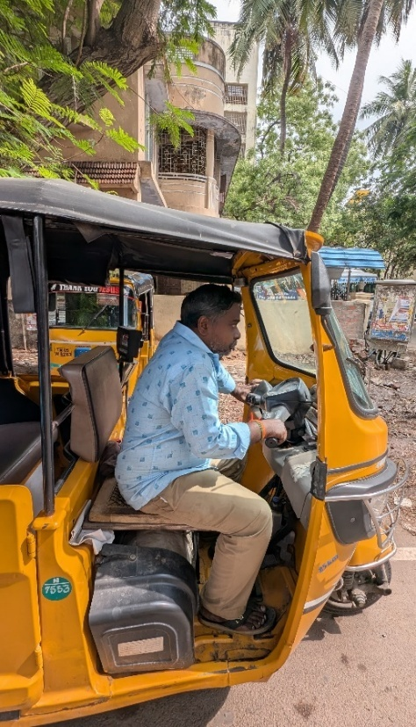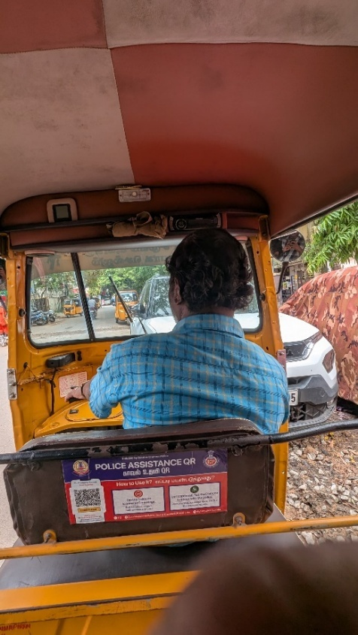

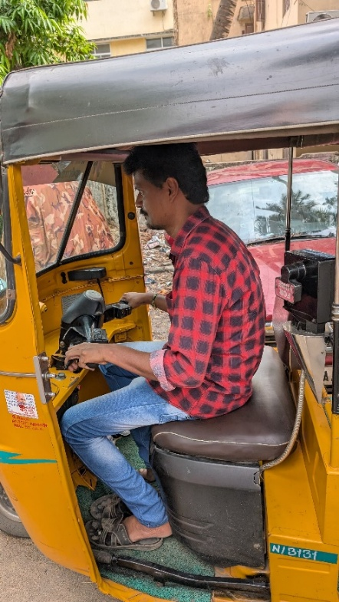

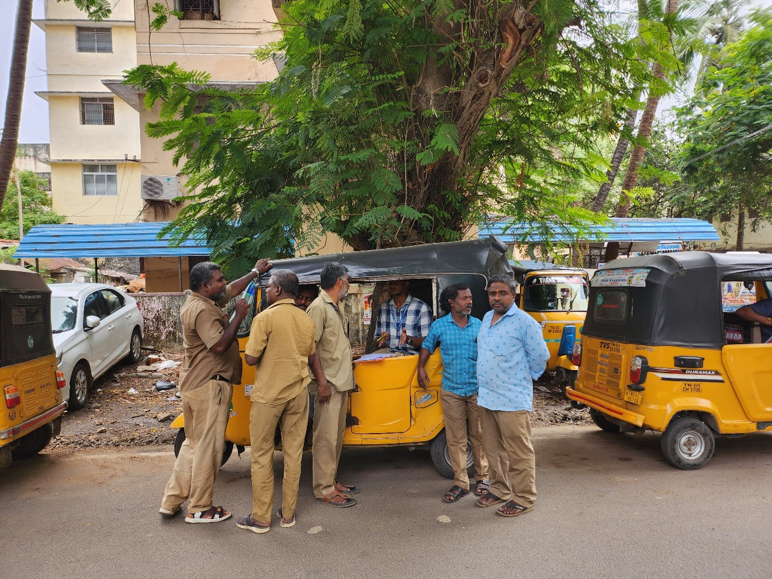 **picture taken while collecting data**

